

**DEPARTMENT OF COMPUTER SCIENCE**

**AND APPLICATIONS**

**IBM PROJECT REPORT**

**Enhancing College Management through Star Schema Analysis**

Submited by

MUHILARASAN.A(222312113)

MANSH.M (222312129)

**BACHELOR OF SCIENCE IN COMPUTER**

**SCIENCE WITH ARTIFICIAL INTELLIGENCE**

*Under the guidance of*

*Ms Subha sri - Corporate Trainer*

**2023 - 2024**

# INTRODUCTION

In this project, we collected datasets containing information on institute names, institute IDs, student names, student IDs, ci es, and states from across all states in India using Kaggle. For Business Intelligence purposes, we utilized a tool called IBM Cognos, through which we aligned data with lists, cross-tabulations,

and various visualizations such as pie charts, bar charts, column charts, and local on charts.

# ABSTRACT

College Insights is a transformative project designed to enhance college management systems by leveraging a star schema data model. This project integrates diverse data sources, including student records, course enrollment, faculty information, and administrative data, to provide real- me insights and ac tionable recommendations . By analyzing this comprehensive dataset, College Insights enables colleges to make informed decisions in critical areas such as student performance tracking, resource allocation, scheduling, and institutional planning. This project aims to optimize operational efficiency, improve student success rates, and enhance overall organizational effectiveness. College Insights revolutionizes college management by harnessing the power of data analysis for smarter decision-making and continuous improvement.

## INSTITUTE DATABASE

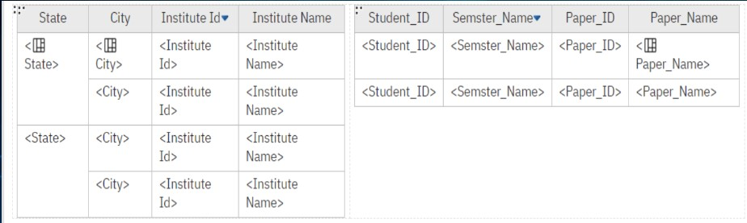

### OUTPUT

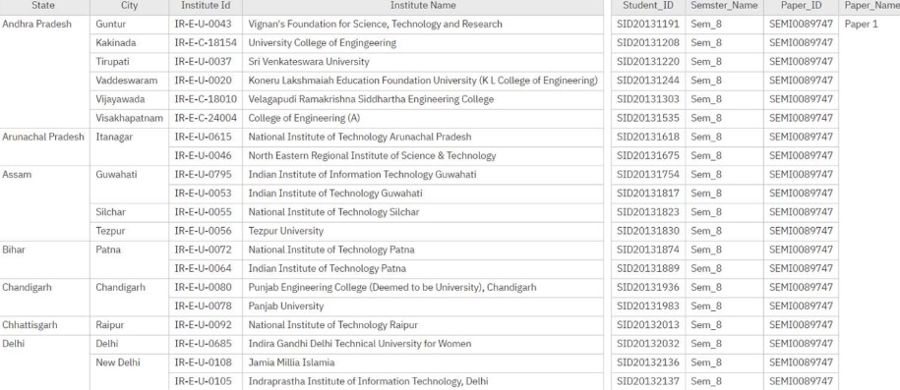

**CROSS TAB**

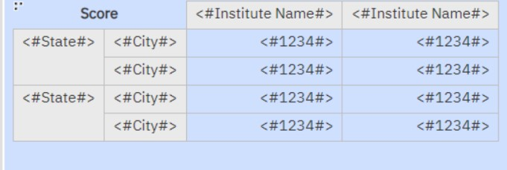

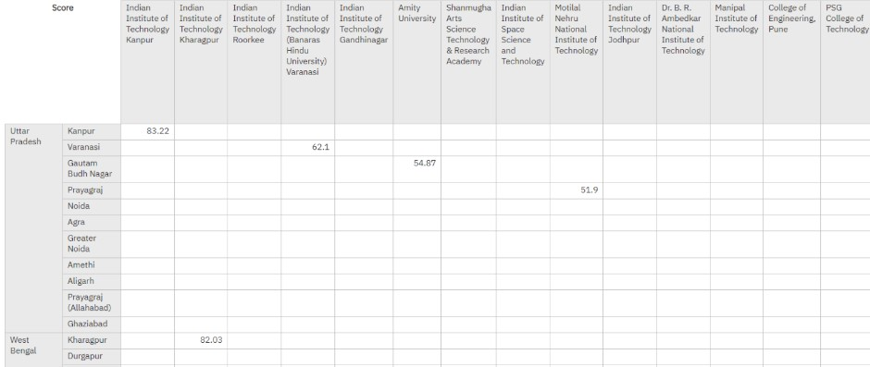

### DISTRIBUTION OF STUDENTS BY SEMESTER

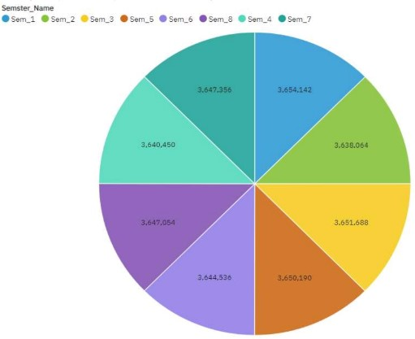

***MARK VS SEMESTER***

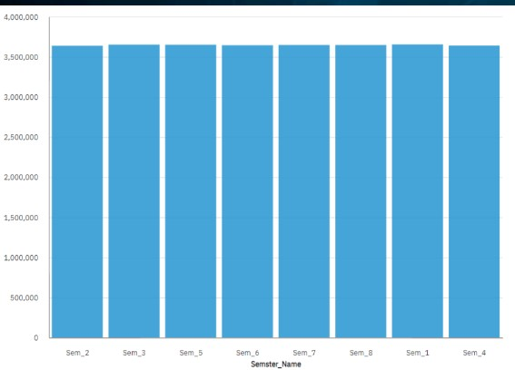

### SEMESTER-WISE DISTRIBUTION OF PAPER SUBMISSIONS

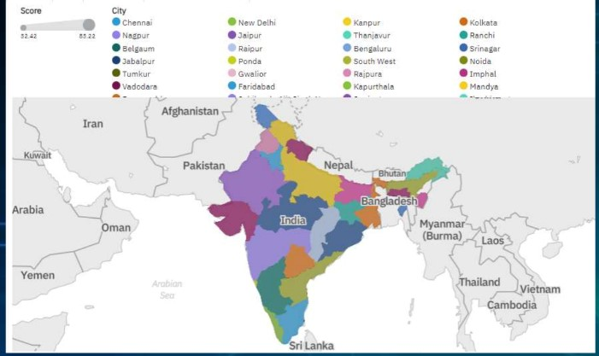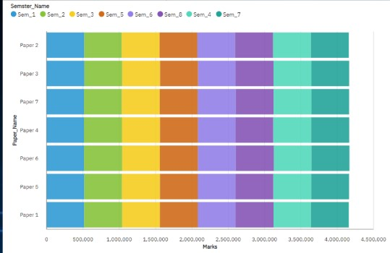

### IIT COLLEGE WHERE LOCATED IN ALL OVER INDIA COLLEGE ADMINISTRATIVE DIVISION OF TAMILNADU

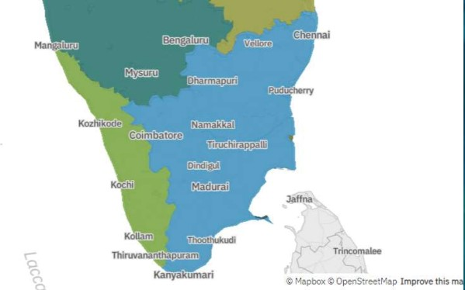

### DASHBOARD

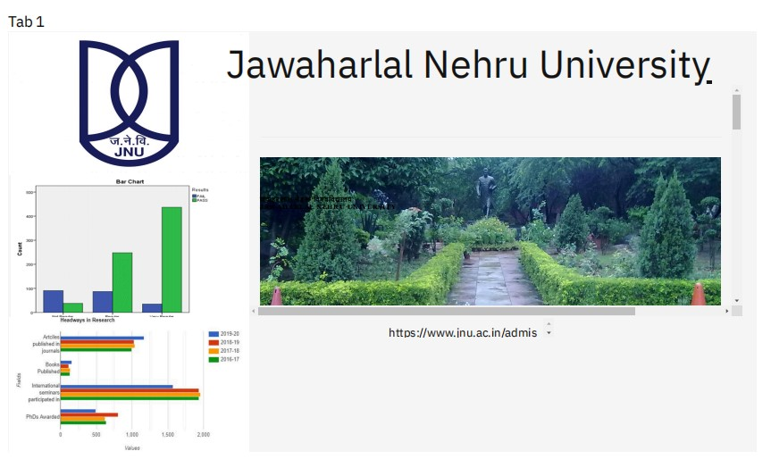

## **Output link**

https://us1.ca.analytics.ibm.com/bi/?perspective=dashboard&pathRef=.my_folders%2Fjnu%2Bdashboard&action=view&mode=dashboard&subView=model0000018f0960b58b_00000002

## CONCLUSION

Our project has used IBM COGNOS Analytics to study the students detail from various colleges across India. we have taken about 10 Datasets from Kaggle and analysed the data using the tools like Lists, Tables, and visualizations.We have also included our the dashboard of JNU(Jawaharlal Nehru University) which gave us the data about the students performance in their exams and found that their performance has been increasing year by year and also it shows the data about the students participating in their extra-curriculars like publishing articles in journals, publishing books, participation of students in international seminars and no. phDs awarded.By this we can analyse the operational efficiency, improve student success rates, and enhance overall organizational effectiveness.